INTERNATIONAL PHOTOGRAPHY COMPETITION 2026
Organised by the Socio-Cultural Commission of the IPA Arts and Culture Project

ENTRY FORM 2026
Name:
IPA Section:
Category:
Address:
Email:

Brief description of every photo submitted:

By submitting these photos, I and all persons shown in the photos authorize the IPA to use the photos for this competition, in IPA publications, on IPA websites and social media.
Please submit all photos together with this form at: anetasobieraj@ipapolska.pl
Aneta Sobieraj will be the contact person (Arts and Culture Project Member)

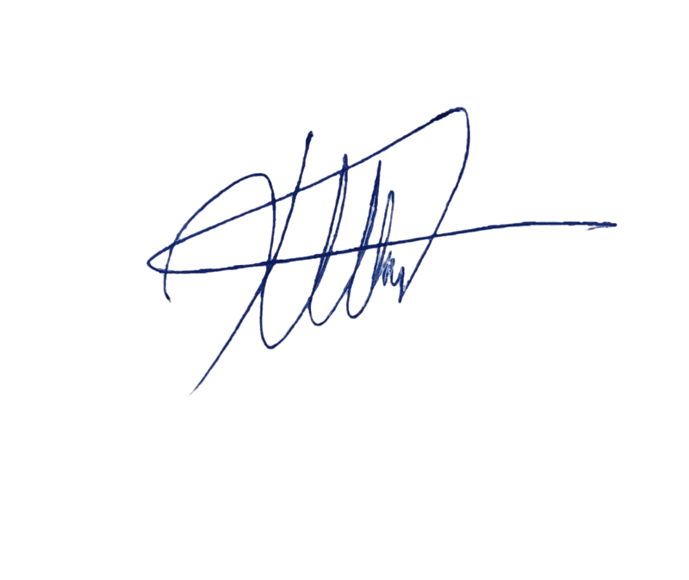
Christos Parginos

Chair Socio-cultural commission

