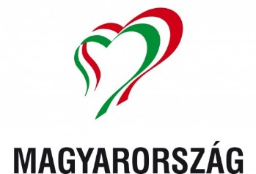

REGISTRATION FORM
IPA HUNGARIAN SECTION –
35TH ANNIVERSARY
Budapest, 18-21. June 2026

Surname
First name/s
Date of birth
Phone number
E-Mail
Home address
Passport details
Function IPA
Accommodation | Hotel Benczúr  Single room  Double room
Surname, first name, date of birth of accompanying person
Passport details of accompanying person
Arrival by | Airplane (Budapest)  Train (Budapest)  Car (Hotel Benczúr)
Flight number or train number | -
Arrival at
Departure
Parking needed | Yes / No
Vegetarian Food needed | Yes / No

BOOKING :
FULL COSTS OF THE PROGRAMS: 380,- €/Person/in a double room. 470,- €/Person/ in a single room.
The program cost includes: participation at each program, meals, drink (limited drinks), transfer to the locations of the programs, the transfer and the gifts. The transfer is just on the 18th June (arrival’s day) and the 21th of June (departure day). Costs do not include parking (about 13,- €/day).
APPLICATION AND PAYMENT DETAILS:
Application deadline: 30th April 2026. Advance payment – 200 EURO/person at the application. Remaining part has to be paid until 30th April 2026.
Cancellation with full refund till 15th May 2026, after that date we cannot refund advance payments.
APPLICATION AND INFORMATION: Maria Mészáros president mmarcsi.ipahun@gmail.com (English, German, Italian)

Please transfer participation costs on following bank account

Name of account owner: IPA MAGYAR SZEKCIÓ
Account number: 11705008-20415891-00000000
Name of the bank: OTP Bank Nyrt.
Address: H-1052 Budapest, Deák Ferenc Street 7-9.
IBAN : HU87 11705008-20415891-00000000
BIC (SWIFT): OTP VHUHB

In case of any questions, please contact : mmarcsi.ipahun@gmail.com

